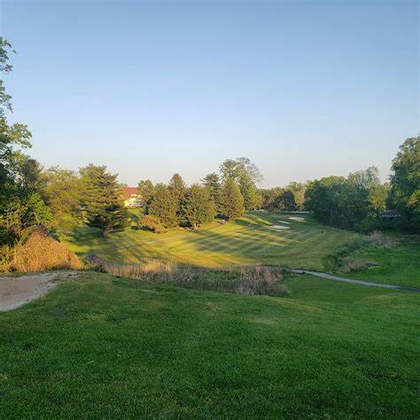
CHELTENHAM VOLUNTEER FIRE COMPANY
ANNUAL GOLF OUTING
“NEIGHBORS HELPING NEIGHBORS”
SINCE 1896
MONDAY JUNE 13, 2022
MELROSE COUNTRY CLUB
7600 Tookany Creek Pkwy, Cheltenham, PA 19012
$99.00 PER GOLFER
Registration 7:30 AM
Scramble/Shot gun start at 9:00 AM
Buffet Lunch/Awards 1:00 PM – 4:00 PM
If interested, contact Scott Lynch
scottlynch@comcast.net
267-767-7471
REGISTRATION
www.cheltenhamfirecompany.org

